**8-BIT MULTIPLICATION**

**EXP NO: 3**

**AIM:** To write an assembly language program to implement 8-bit multiplication using 8085 processor.

**ALGORITHM:**

1. Start the program by loading a register pair with the address of memory location.
2. Move the data to a register.
3. Get the second data and load it into the accumulator.
4. Add the two register contents.
5. Increment the value of the carry.
6. Check whether the repeated addition is over.
7. Store the value of product and the carry in the memory location.
8. Halt.

**PROGRAM:**

LDA 8500

MOV B, A

LDA 8001

MOV C, A

CPI 00

JZ LOOP

XRA A

LOOP1: ADD E

DCR C

JZ LOOP

JMP LOOP1

LOOP: STA 8002

RST 1

**INPUT:**

DATA SEGMENT

NUM1 DB 05H ; multiplicand

NUM2 DB 04H ; multiplier

DATA ENDS

CODE SEGMENT

ASSUME CS:CODE, DS:DATA

START:

MOV AX, DATA

MOV DS, AX

; Load inputs

MOV AL, NUM1 ; AL = multiplicand

MOV BL, NUM2 ; BL = multiplier

XOR AH, AH ; AX = 0 (clear high byte, AX will hold result)

LOOP1:

ADD AH, AL ; AH = AH + AL

DEC BL ; decrement multiplier

JNZ LOOP1 ; loop until BL = 0

; Result is now in AH

HLT

CODE ENDS

END START

**OUTPUT:**

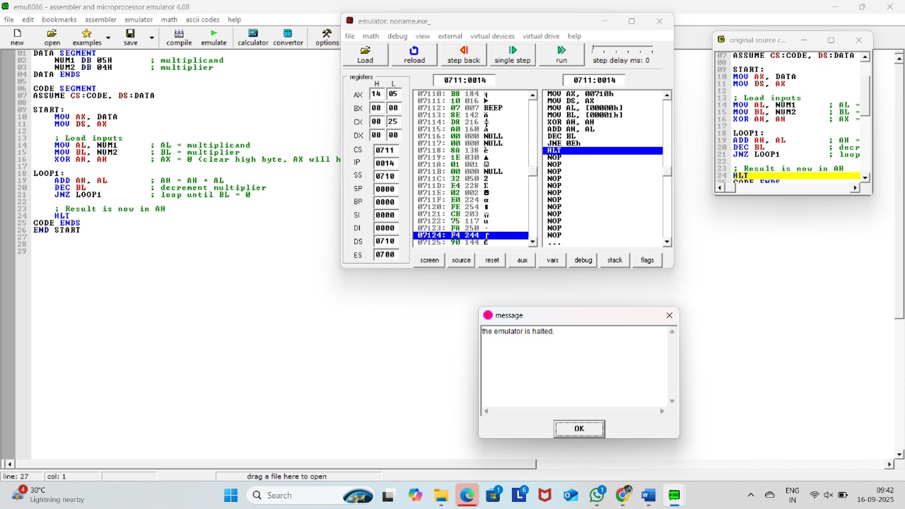

**RESULT:** Thus the program was executed successfully using 8085 processor simulator.